Name: Michael Small
Major: Public Health
Date: Nov 15, 2019
Semester: Fall 2019
Undergraduate Program Director: Marc D. Weiner, J.D., Ph.D
UPD Contact Information:
Room 186 Bloustein
(848) 932-2765
mdweiner@ejb.rutgers.edu

I. Major Options - What options are offered within the major? How do they differ?

There are no options offered within the major. But there is a difference between pre-reqs between SAS and SEBS. The pre-reqs for SEBS students include Chemistry I & II. SEBS students also have to take Intro to Experimentation.

II. Total number of students within the major
This major is offered by SEBS, SAS and Bloustein. The total number of students in the major is 484, of which there are 64 students from School of Environmental and Biological Sciences.

III. Goals within the major - What are expectations of students post-graduation?
The goal of the major is to be competent and well-versed in a variety of public health concentrations. There are many graduates that are participating in every area of healthcare. There are also a good number of students who go off attend graduate school or a professional program like med school, law school, or an MPH (Master’s in Public Health) program. The majority of students go into the workforce.

IV. Major Courses - What is the goal of each course? What should students be
Learning?
Taken from: https://bloustein.rutgers.edu/wp-content/uploads/2013/12/EJB-publichealth-learninggoals.pdf
Discuss the fundamental values and philosophy of public health, including its history as well as its contemporary global and societal functions.
- Relevant courses include:
  - 101 Introduction to Planning, Policy and Health
  - 201 Principles of Public Health
  - 240 Global Health Perspectives
  - 335 Epidemiology
  - 339 Public Health Literature
Critically use and evaluate public health data, based on an understanding of the key concepts,
methods and tools of data collection and analysis.
- Relevant courses include:
  - 201 Principles of Public Health
  - 335 Epidemiology
  - 395 Research Methods
  - 499 Internship
Identify key issues in population health and health policy, including the processes, approaches and interventions used to address these challenges.
- Relevant courses include:
  - 212 Introduction to Health Disparities
  - 335 Epidemiology
  - 339 Public Health Literature
  - 395 Research Methods
Describe the underlying scientific principles utilized in public health that contribute to our
understanding of human health, and discuss how this knowledge informs health promotion and
health protection activities.
- Relevant courses include:
  - 201 Principles of Public Health
  - 212 Introduction to Health Disparities
  - 335 Epidemiology
  - 339 Public Health Literature
  - 395 Research Methods
Assess the impact and intersection of historical, cultural, political, environmental, behavioral,
biological and socioeconomic factors on population health and health disparities.
- Relevant courses include:
  - 201 Principles of Public Health
  - 212 Introduction to Health Disparities
  - 240 Global Health Perspectives
  - 339 Public Health Literature
  - 395 Research Methods
Be able to plan, assess and evaluate public health research and policy interventions based on the
best available evidence.
- Relevant courses include:
  - 101 Introduction to Planning, Policy and Health
  - 300 Writing for Professionals
  - 450 Leadership Seminar
  - 499 Internship
Describe the organization, financing, and delivery of health services and public health systems.
- Relevant courses include:
  - 101 Introduction to Planning, Policy and Health
  - 201 Principles of Public Health
  - 212 Introduction to Health Disparities
  - 240 Global Health Perspectives
  - 339 Public Health Literature
Evaluate the legal, ethical and economic aspects of health care and public health policy.
- Relevant courses include:
  - 212 Health Disparities
  - 339 Public Health Literature
  - 356 Public Health Law and Ethics
  - 395 Research Methods
Prepare written and oral communication to convey public health concepts and analysis clearly and persuasively to both professional and general audiences.
- All courses relevant, especially:
  - 300 Writing for Professionals
  - 339 Public Health Literature
  - 395 Research Methods
  - 450 Leadership Seminar
  - 499 Internship

V. Concerns/Student issues with classes? How to resolve, suggestions?
In recent discussions with public health majors, I have noticed that the Biology and Chemistry prerequisites were the biggest hurdles to overcome in claiming the major. However, I was informed this semester that starting in the Fall 2020 class there will changes to the requirement for chemistry and biology. They are highlighted below in the “changes to the major section”. Outside of the pre-requisite requirements there have not been any other major complaints.

VI. Things going on within the major (Research, Visitors, Talks, Seminars within the
major)
Anything that is happening in Bloustein is sent out through an email to all students that have a major within Bloustein.

VII. Research Opportunities

There is going to be a new Honors Program for public health students starting in Fall 2019. Applications should be open by Feb 1 and close (tentatively) by May 115. Emails will be sent out to the Class of 2020 as rising seniors are only allowed to apply.
In order for a student to qualify for this Honors Program they must have a 3.0 GPA overall or at least 3.6 within the major. Students also need two letters of recommendation from their Research Methods professor and a 300 level public health professor.
The program will take place over two semesters. The first semester will be a small class no more than 12 - 15 students that will go over public health research, the IRB process, IRB approval for students, and learning more about quantitative research. The second semester will be dedicated to research. Students in the program are not guaranteed research and will need to find a professor on their own.

Update Fall 2019: 5 students qualified for the program, and four are currently enrolled.

For additional information: https://bloustein.rutgers.edu/undergraduate/bloustein-honors/. Note there is a tab for more information on specifically how the BHRP and the George H. Cook Scholars Program work in tandem.

Public Health majors can also do research through Aresty or contact a professor on their own.

VIII. Job Outlook, suggestions for students in this major (ex: organizations to join, news
to pay attention to)
Students are able to find jobs because they take advantage of the network at Rutgers and at Bloustein. They network with faculty members that have connections in hospitals.
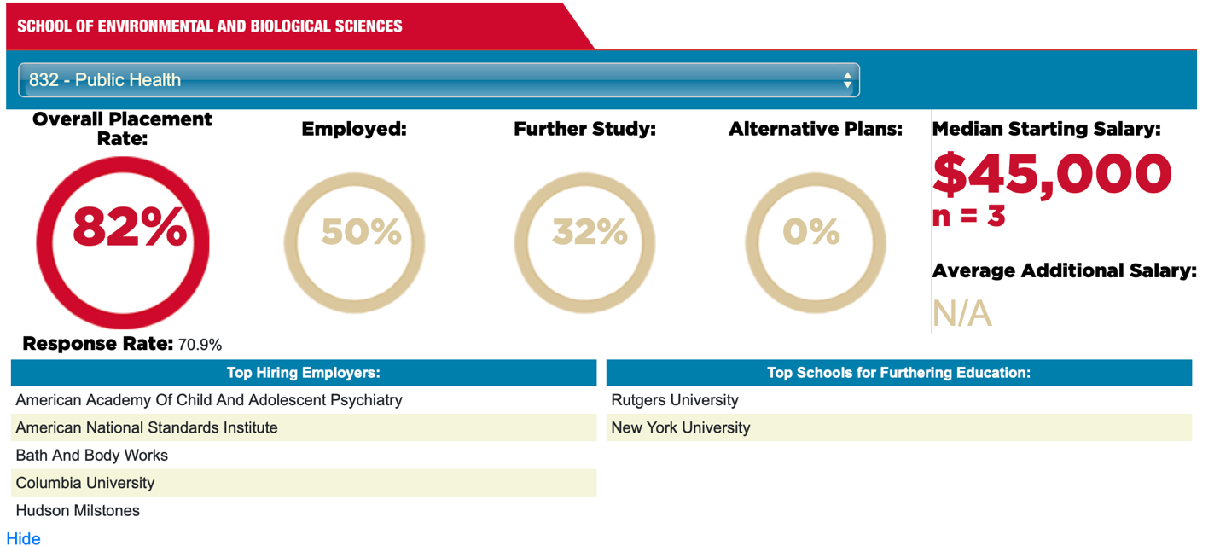

IX. Changes within the major in the upcoming year?
The Fall of 2019 will see the following changes to the SEBS requirements for claiming the Public Health major:
Any ONE of the following Human Biology courses:
Course number | Credits | Course Name
01:119:103 | 4 | Principles of Biology
01:119:115 | 4 | General Biology I
01:119:116 | 4 | General Biology II
01:119:127 | 4 | Anatomy & Physiology I
01:119:128 | 4 | Anatomy & Physiology II
01:119:131 | 3 | Microbiology for the Health Sciences
01:119:150 | 3 | Biology, Society, and Biomedical Issues
01:119:160 | 3 | Biology, Society, and Ecological Issues
11:374:101 | 3 | Introduction to Human Ecology

Any ONE of the following Chemistry courses:
- 01:160:127, Impact of Chemistry (3 credits);
- 01:160:128, Chemistry of Life (3 credits); or
- 01:160:161 or 01:160:162, General Chemistry I or II (4 credits each)

These changes were made largely in part due to the concerns of students in completing the general biology and general chemistry tracks in order to claim the major. The faculty voted to make these changes in response to those concerns.

All other requirements still stand, in this report we are simply highlighting the changes made with regard to the science requirements.

Additionally, with regards to changes to the major, there are none planned; the public health major, however, is in its self-study year for continuing accreditation by the Council on Education for Public Health. It was first accredited in 2016 for a five-year term; that accreditation term ends June 30, 2021, and the self-study is the first step in the process of re-accreditation. This is a routine process and there are no issues anticipated with obtaining re-accreditation

X. Other Suggestions
There are discussions about a potential Canvas site for public health majors so that they can find all the resources for the undergrad public health program. This could also include reminders about deadlines of certain applications.

