Page of 2 5
Name: ______Gabrielle Jacob__________
Major:_____Public Health______________
Date:____Nov 15, 2018______________
Semester: _____Fall ____________
Undergraduate Program Director: Christina Torian
UPD Contact Information:
Room 186 Bloustein
(848) 932-2726
christina.torian@rutgers.edu
I. Major Options - What options are offered within the major? How do they differ?

There are no options offered within the major. But there is a difference between pre-reqs between SAS and SEBS. The pre-reqs for SEBS students include Chemistry I & II. SEBS students also have to take Intro to Experimentation.

II. Total number of students within the major
41
III. Goals within the major - What are expectations of students post-graduation?
I think of of the goals of the major is to be competent and well-versed in a variety of public health concentrations. There are many graduates that are participating in every area of healthcare. There are also a good number of students who go off attend graduate school or a professional program like med school, law school, or an MPH (Master’s in Public Health) program. The majority of students go into the workforce.

IV. Major Courses - What is the goal of each course? What should students be
Learning?
Taken from: https://bloustein.rutgers.edu/wp-content/uploads/2013/12/EJB-publichealth-learninggoals.pdf
Discuss the fundamental values and philosophy of public health, including its history as well as its contemporary global and societal functions.
- Relevant courses include:
  - 101 Introduction to Planning, Policy and Health
  - 201 Principles of Public Health
  - 240 Global Health Perspectives
  - 335 Epidemiology
  - 339 Public Health Literature
Critically use and evaluate public health data, based on an understanding of the key concepts,
methods and tools of data collection and analysis.
- Relevant courses include:
  - 201 Principles of Public Health
  - 335 Epidemiology
  - 395 Research Methods
  - 499 Internship
Identify key issues in population health and health policy, including the processes, approaches and interventions used to address these challenges.
- Relevant courses include:
  - 212 Introduction to Health Disparities
  - 335 Epidemiology
  - 339 Public Health Literature
  - 395 Research Methods
Describe the underlying scientific principles utilized in public health that contribute to our
understanding of human health, and discuss how this knowledge informs health promotion and
health protection activities.
- Relevant courses include:
  - 201 Principles of Public Health
  - 212 Introduction to Health Disparities
  - 335 Epidemiology
  - 339 Public Health Literature
  - 395 Research Methods
Assess the impact and intersection of historical, cultural, political, environmental, behavioral,
biological and socioeconomic factors on population health and health disparities.
- Relevant courses include:
  - 201 Principles of Public Health
  - 212 Introduction to Health Disparities
  - 240 Global Health Perspectives
  - 339 Public Health Literature
  - 395 Research Methods
Be able to plan, assess and evaluate public health research and policy interventions based on the
best available evidence.
- Relevant courses include:
  - 101 Introduction to Planning, Policy and Health
  - 300 Writing for Professionals
  - 450 Leadership Seminar
  - 499 Internship
Describe the organization, financing, and delivery of health services and public health systems.
- Relevant courses include:
  - 101 Introduction to Planning, Policy and Health
  - 201 Principles of Public Health
  - 212 Introduction to Health Disparities
  - 240 Global Health Perspectives
  - 339 Public Health Literature
Evaluate the legal, ethical and economic aspects of health care and public health policy.
- Relevant courses include:
  - 212 Health Disparities
  - 339 Public Health Literature
  - 356 Public Health Law and Ethics
  - 395 Research Methods
Prepare written and oral communication to convey public health concepts and analysis clearly and persuasively to both professional and general audiences.
- All courses relevant, especially:
  - 300 Writing for Professionals
  - 339 Public Health Literature
  - 395 Research Methods
  - 450 Leadership Seminar
  - 499 Internship

Page of 4 5
V. Concerns/Student issues with classes? How to resolve, suggestions?
One of the biggest issues in the public health major is part of the pre-reqs which include Bio I&II and Chem I&II. Many public health majors struggle to do well in the classes. Another concern is finishing on time, some students may have come from different majors with different requirements and cannot finish on time. Or others are doing their internship (required) the summer after they graduate.

I do not think that there is an easy way to resolve these problems. My suggestion would be for public health majors to form study groups or have bio and chem blocks specifically for public health majors.

VI. Things going on within the major (Research, Visitors, Talks, Seminars within the
major)
Anything that is happening in Bloustein is sent out through an email to all students that have a major within Bloustein.

Page of 5 5
VII. Research Opportunities

There is going to be a new Honors Program for public health students starting in Fall 2019. Applications should be open by Feb 1 and close (tentatively) by May 115. Emails will be sent out to the Class of 2020 as rising seniors are only allowed to apply.
In order for a student to qualify for this Honors Program they must have a 3.0 GPA overall or at least 3.6 within the major. Students also need two letters of recommendation from their Research Methods professor and a 300 level public health professor.
The program will take place over two semesters. The first semester will be a small class no more than 12 - 15 students that will go over public health research, the IRB process, IRB approval for students, and learning more about quantitative research. The second semester will be dedicated to research. Students in the program are not guaranteed research and will need to find a professor on their own.

Public Health majors can also do research through Aresty or contact a professor on their own.

VIII. Job Outlook, suggestions for students in this major (ex: organizations to join, news
to pay attention to)
Students are able to find jobs because they take advantage of the network at Rutgers and at Bloustein. They network with faculty members that have connections in hospitals.
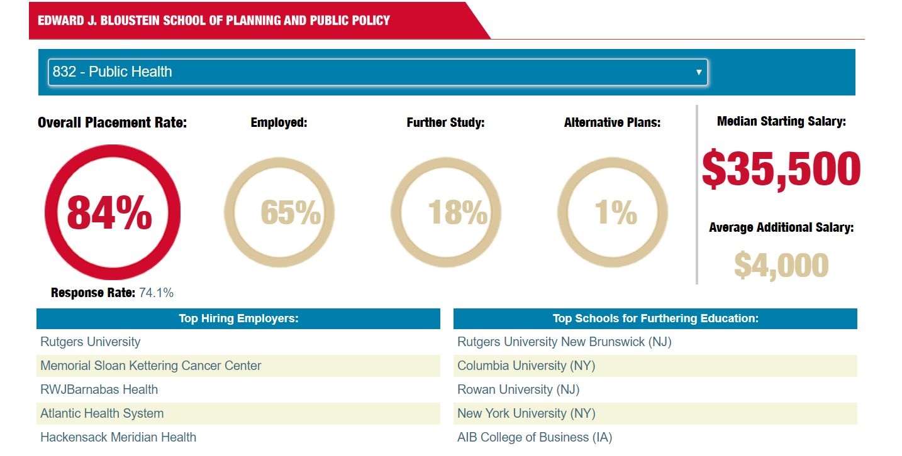

IX. Changes within the major in the upcoming year?
There are talks about changes in the major but this would mostly concern students that are pursuing Public Health through SAS.
X. Other Suggestions
There are discussions about a potential Canvas site for public health majors so that they can find all the resources for the undergrad public health program. This could also include reminders about deadlines of certain applications.

