Page of 1 5
Directions for Undergraduate Program Director Reports:
1. Talk to students in your major, ask around if there are any current academic issues.
(ex: class conflicts within the major, issues with professors, etc)
- Internships
- Independent study- find a professor and pick a topic
- Research
- Facebook for advertising
2. Look at Degree Navigator, write down the course requirements
3. Formulate a list of things you would like to know about the program (corporate
connections with the university, current research projects, opportunities for students
to get involved, etc)
4. Email Undergraduate Program Director and Arrange Appointment
5. Fill out Undergraduate Report Sheet
6. email to vicepresident@sgc.rutgers.edu and complete by December 4th
Page of 2 5
Name: _Madison, Joey_______________
Major:__________EPIB__________________
Date:_________12/21/18_________________
Semester: _______Fall 2018______________
Undergraduate Program Director: ____George Clark__________
UPD Contact Information:
_______gfclark@sebs.rutgers.edu_____________________________________
I. Major Options - What options are offered within the major? How do they differ?
II. Total number of students within the major
- Graduate around 40
- Major- 105
- Minor- 19
- Sustainability minor- 46
III. Goals within the major - What are expectations of student’s post-graduation?
- Students graduating from EPIB will understand and analyze the varied perspectives offered by the social and natural sciences regarding the causes and consequences of social, ecological, and environmental change. This includes interactions among natural resources, climate, population, energy use and technology, health, forces of globalization, social institutions, and cultural values. Students will acquire the skills to use appropriate conceptual and methodological tools to structure inquiries about human-environment interactions. And finally, students will undertake their work guided by ethical considerations. They will identify their own values with respect to environmental, health, and food issues; and they will evaluate and address the ethical dimensions and implications of related problems, assessments, plans, and communication, including their differentiated social impacts.

Page of 3 5
IV. Major Courses - What is the goal of each course? What should students be
Learning? -57 credits
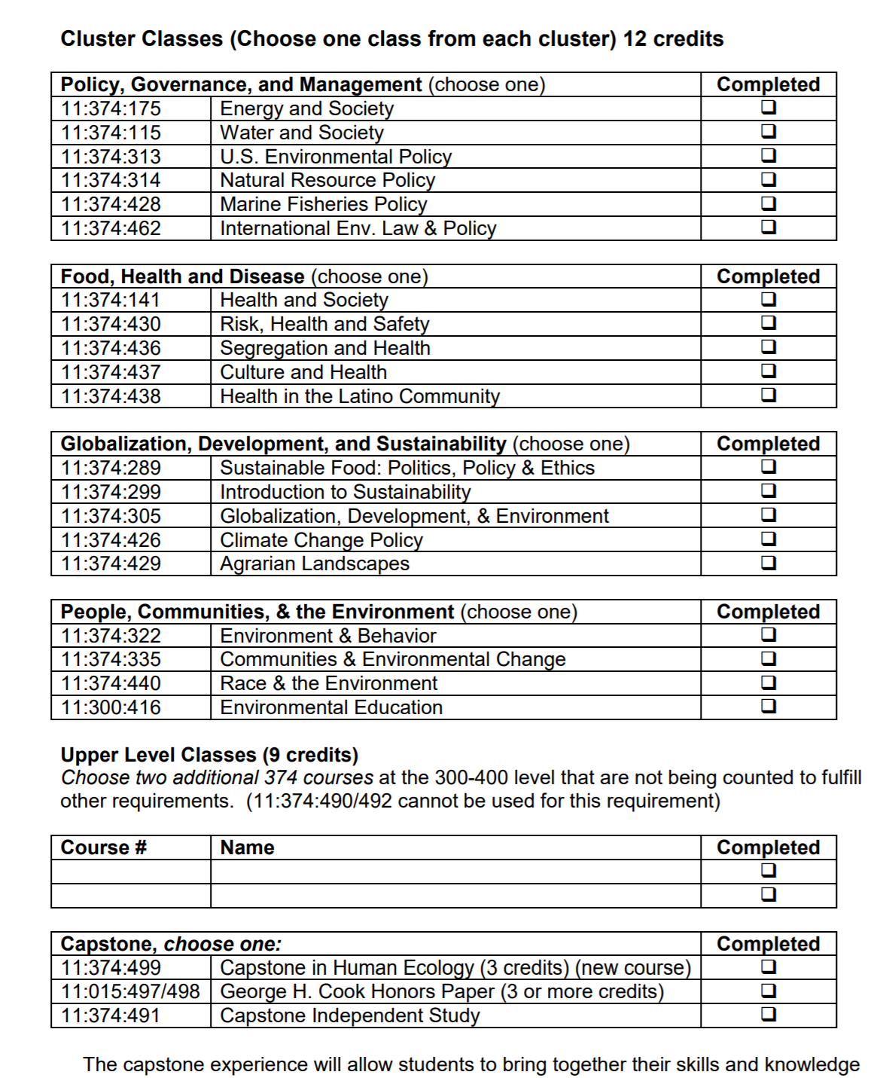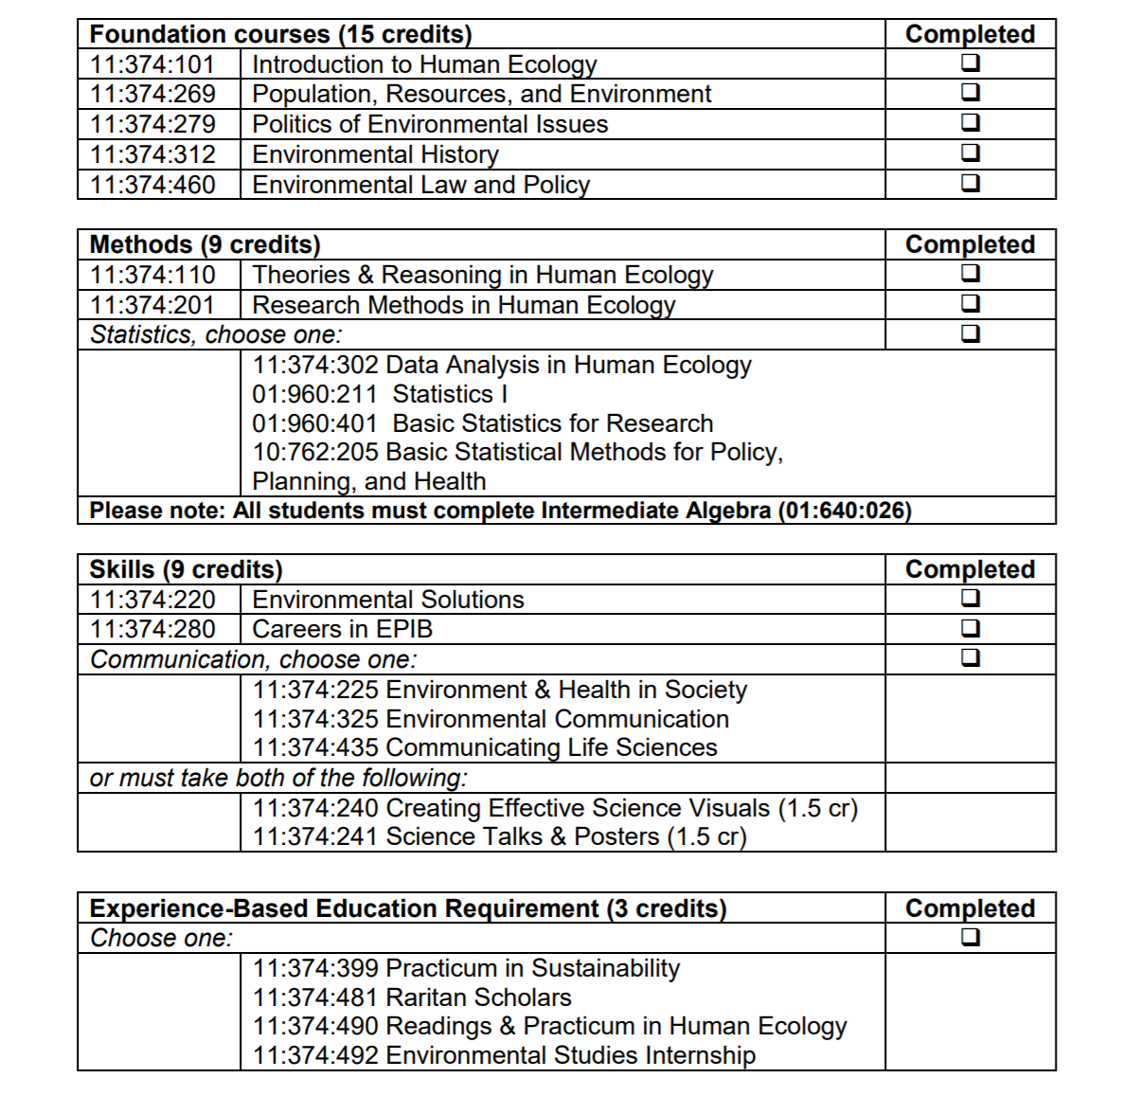Page of 4 5
V. Concerns/Student issues with classes? How to resolve, suggestions?
Below when we talked to students are some concerns they had:
- Internships, Research, Independent Study - finding internships
- Class Schedule - want more diversity with the times classes can be taken
- Science Requirements - would want a possible science requirement such as Biology

Possible Solutions: When discussing with Dr. Clark he said a lot of these are hard to achieve since the major is so small with a limited staff of professors. He said they do make constant improvements to the class schedule available to take during each semester and make sure that no two classes that are needed every overlap. Dr. Clark also said that including a specific science requirement for the major would be difficult since that would require the class to be taken within a different department which has caused issues in the past. In regards to internships, research, independent study there are opportunities that are always posted on the Human Ecology Facebook.

VI. Things going on within the major (Research, Visitors, Talks, Seminars within the
major)
Students should join the Human Ecology Facebook group for updates on research, visitors, talks, and seminars that happen within the major. The Human Ecology Department also hosts the Brown Bag Series and Science Cafe throughout the year that students are always welcomed to attend!
Page of 5 5
VII. Research Opportunities
- Smaller research projects.
- Students are encouraged to reach out to professors instead of waiting for professors to reach out to students. This would also be a helpful tip for students who want to complete an Independent Study.
VIII. Job Outlook, suggestions for students in this major (ex: organizations to join, news
to pay attention to)
- Environmental consulting firms
- DEP *hiring again
- Non-profit
- grad/law school
- Human resources
- Experienced based learning requirement- internship or raritan scholars
  - Student conservation association
IX. Changes within the major in the upcoming year?
- Minor reshuffling courses for scheduling
X. Other Suggestions
- Teaching highly valued

